ASSESSMENT 3

*“SQL TCL COMMANDS, DATA INTEGRITY & CONSTRAINTS ”*



Submitted By

VAIBHAV PATIDAR

IPS ACADEMY, INDORE (M.P.)

**Creating a Employee table named “emp” :**

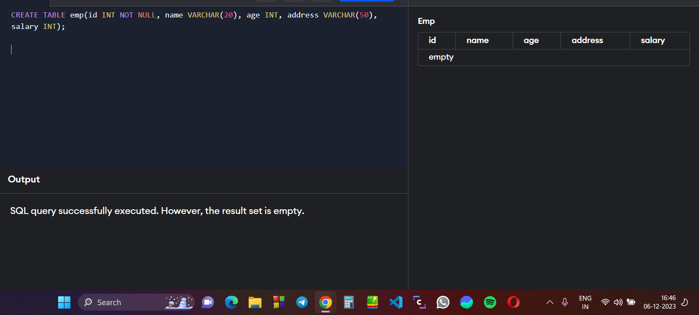

**Add values in table :**

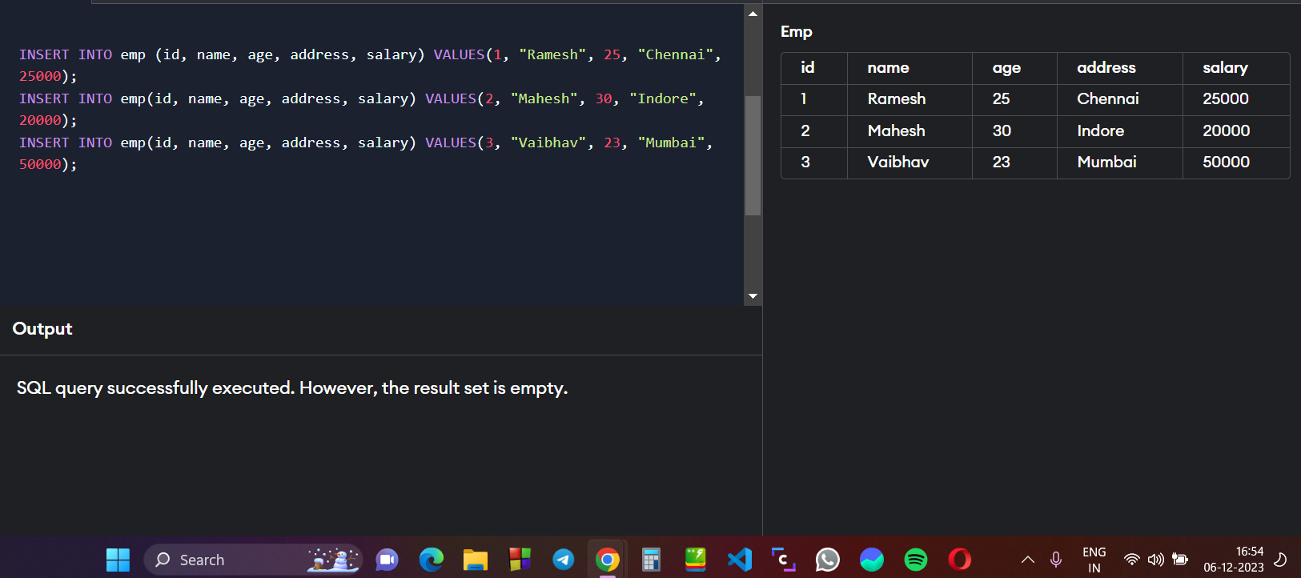

**Use DELETE and COMMIT Command within TRANSACTION :**

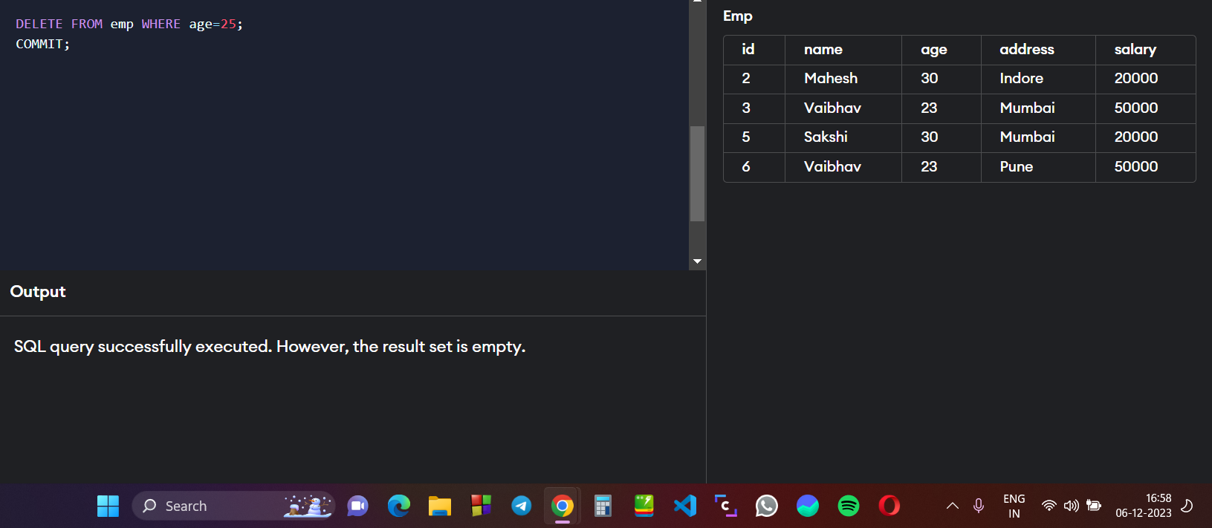

**Using DELETE & ROLLBACK command :**

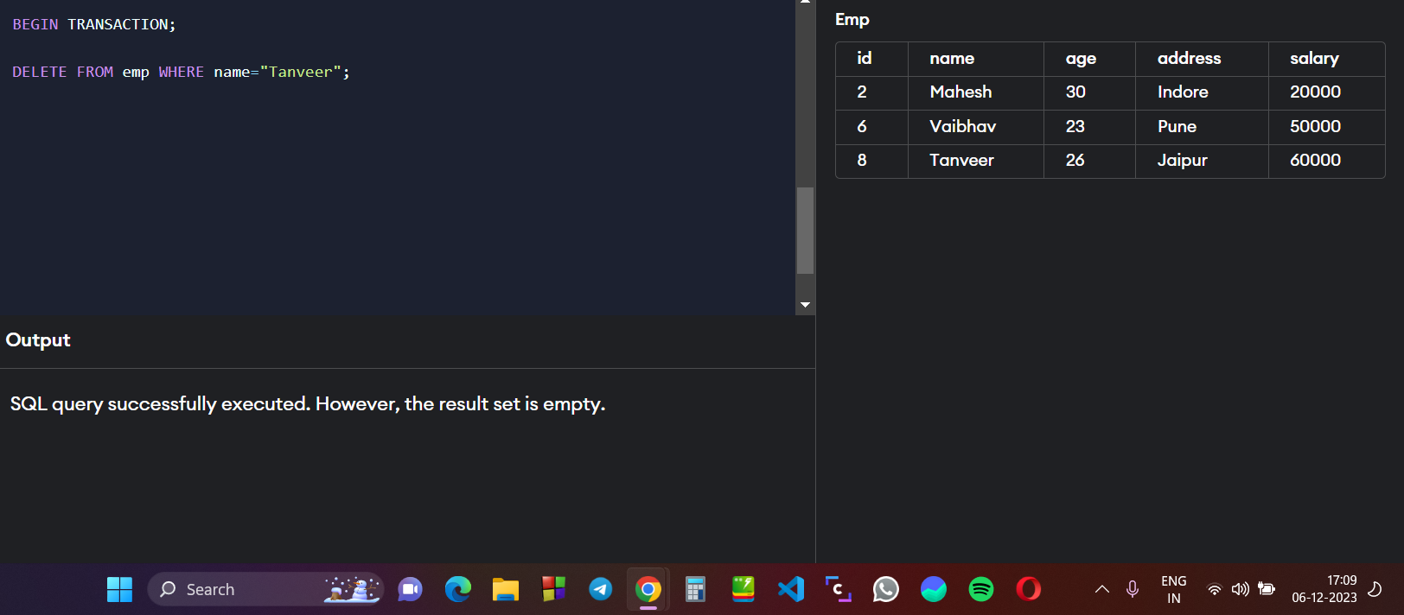

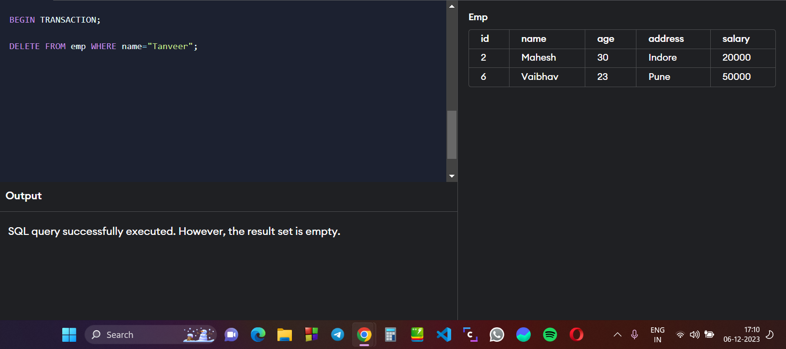

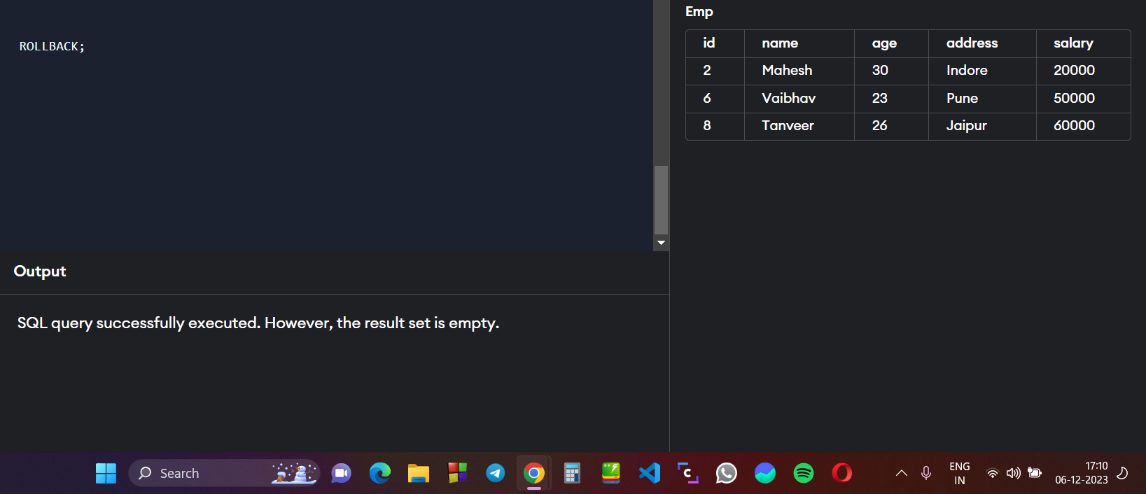

**Creating 2 SAVEPOINTS A & B :**

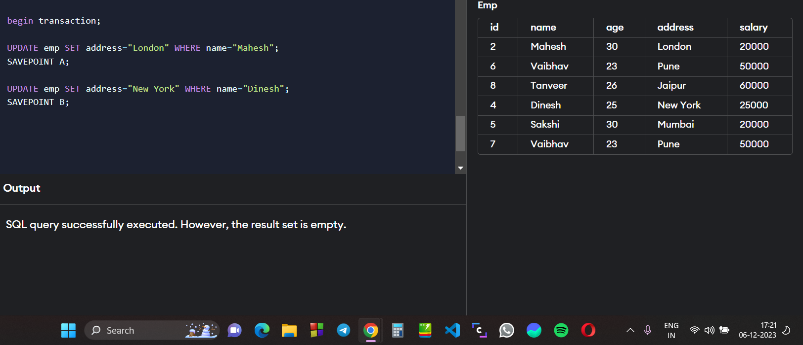

**Now rollback the transaction to savepoint A :**

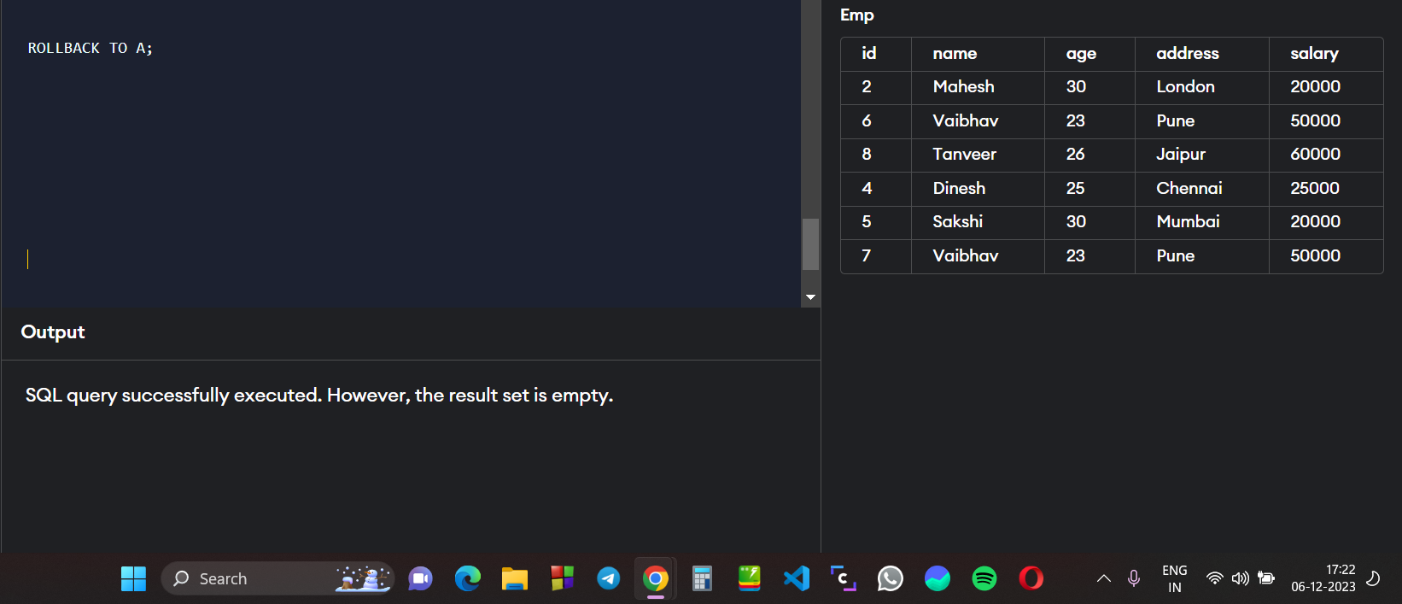

**REMOVE THE savepoint A by using RELEASE SAVEPOINT :**

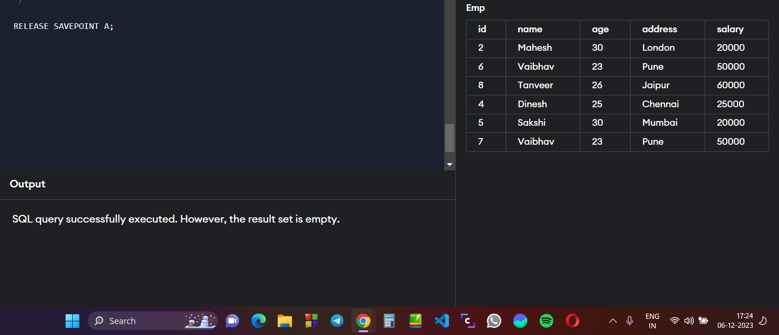

***SET Operators in SQL***

***“UNION”, “INTERSECTION”, “UNION ALL”, “MINUS”***

**Create 2 table emp1 and emp2 for UNION operator :**

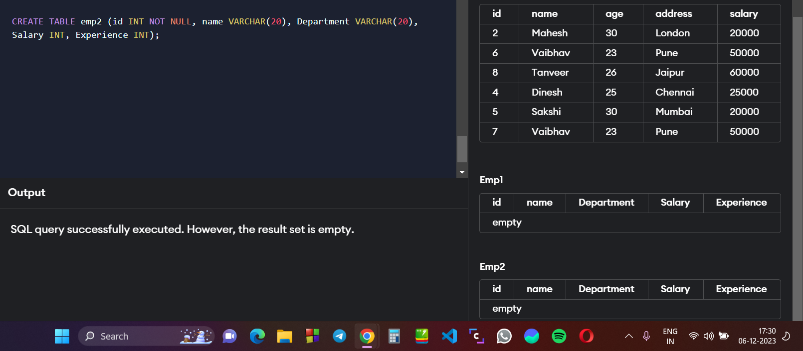

**Adding data in emp 1 :** 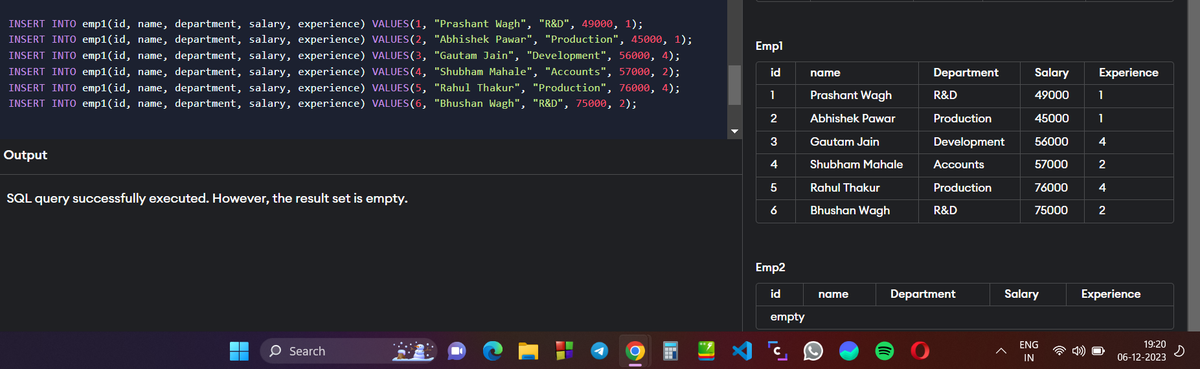

**Adding data in emp2 :**

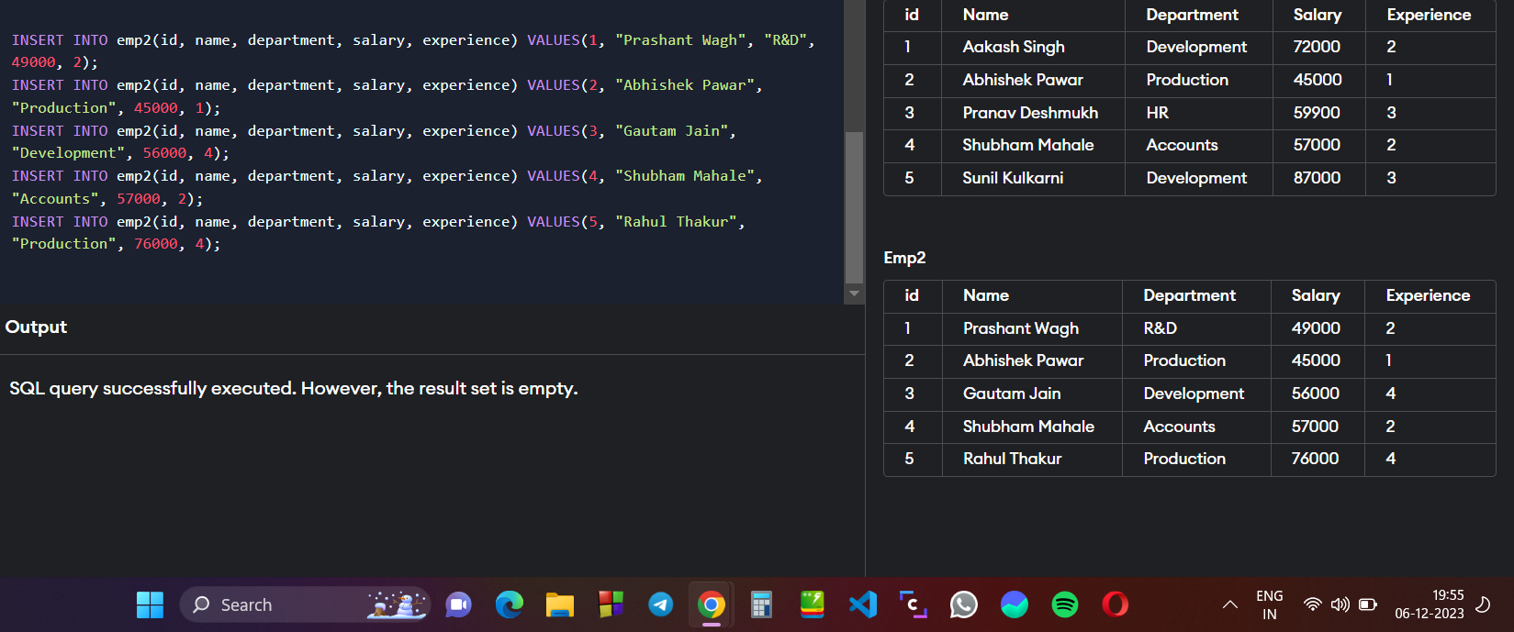

**Use the UNION keyword to add both the tables : emp1 & emp2**

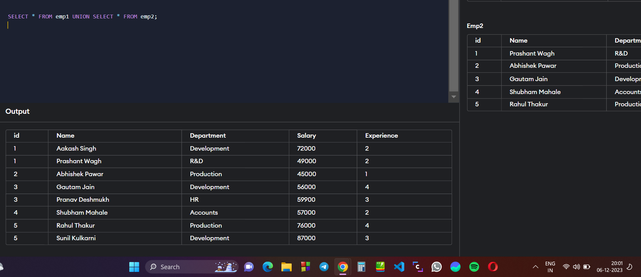

**Using the UNION ALL command to add data of emp1 & emp2:**

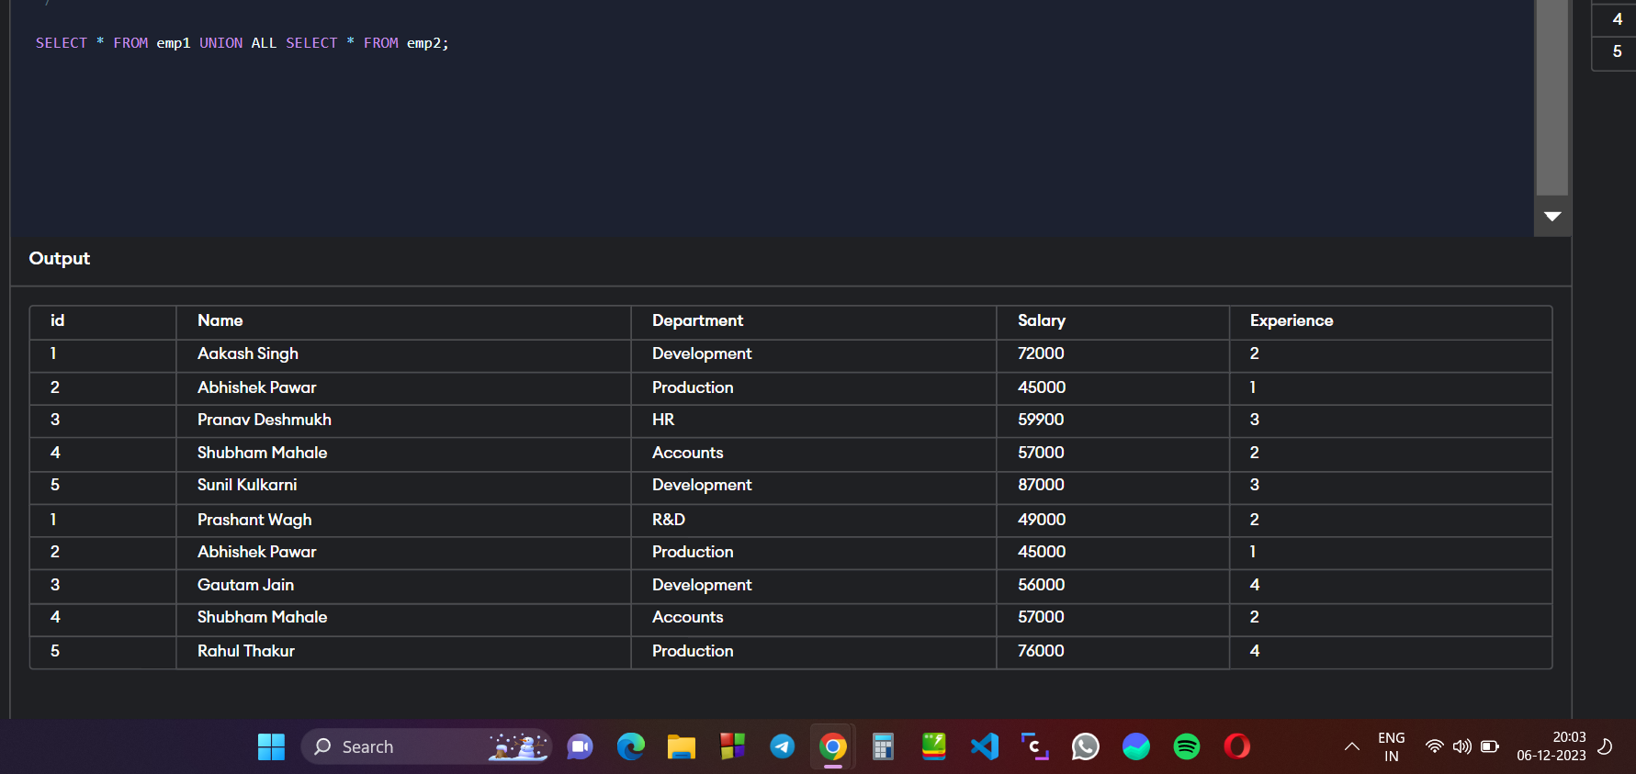

**Using INTERSECTION COMMAD to print common elements in emp1 and emp2 :**

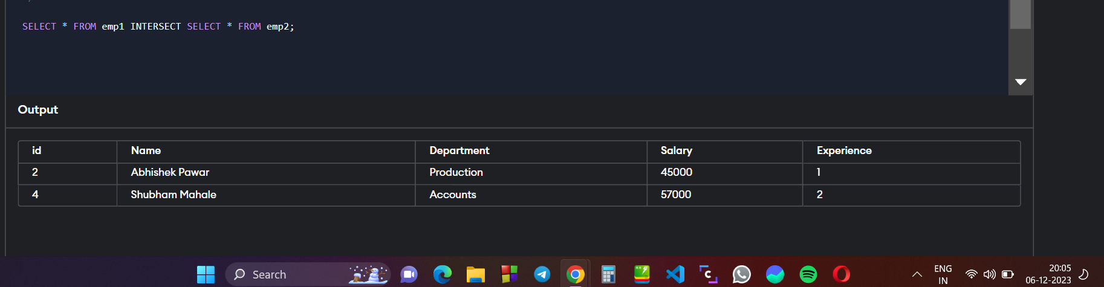

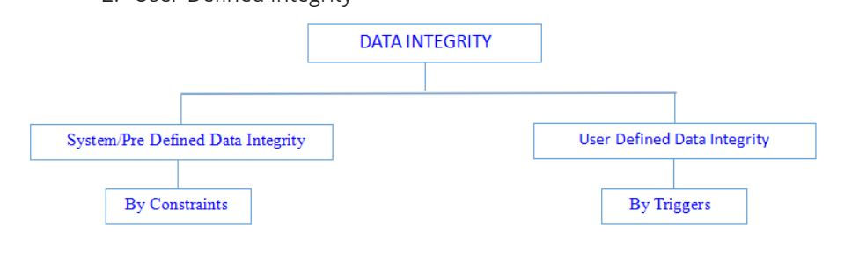

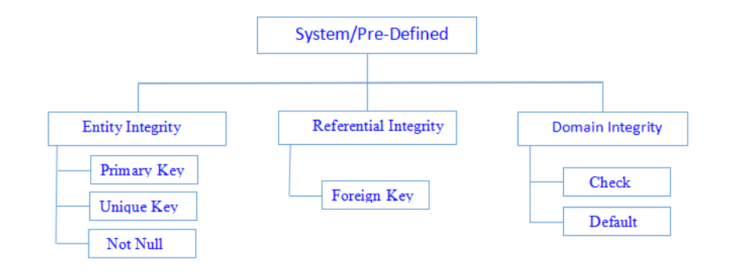

***ENTITY INTEGRITY***

**Using UNIQUE KEY Constraint to create table with UNIQUE Id and Price :**

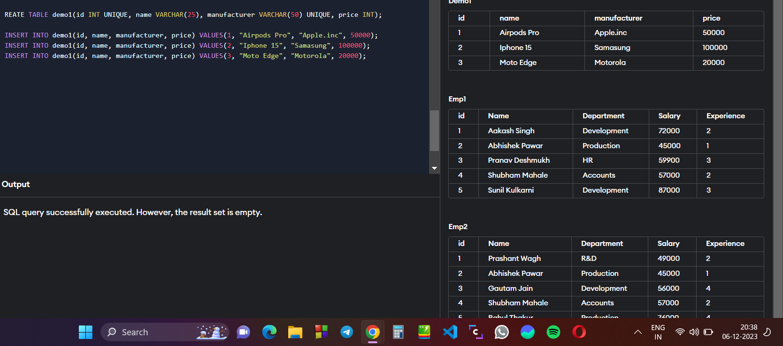

**Using NOT NULL Constraint in Demo table :**

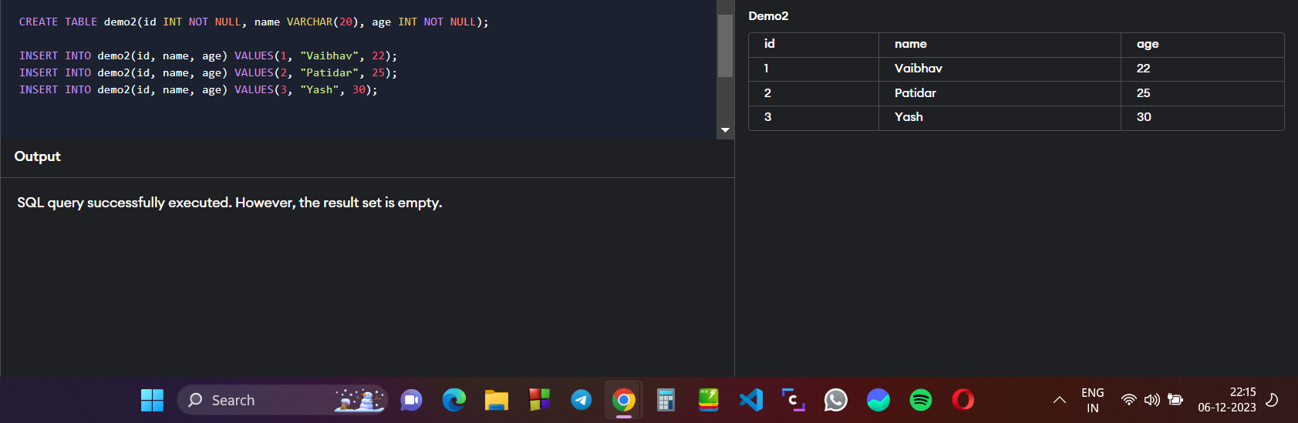

**Using PRIMARY KEY Constraint to assign primary keys to table demo3 :**

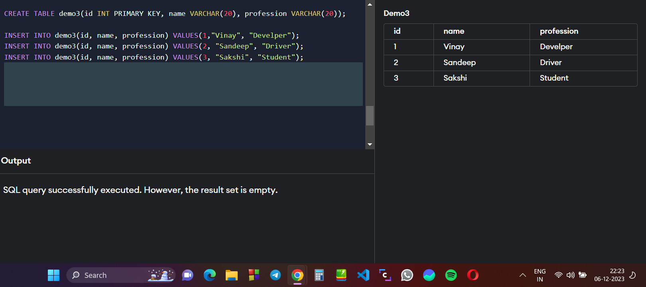

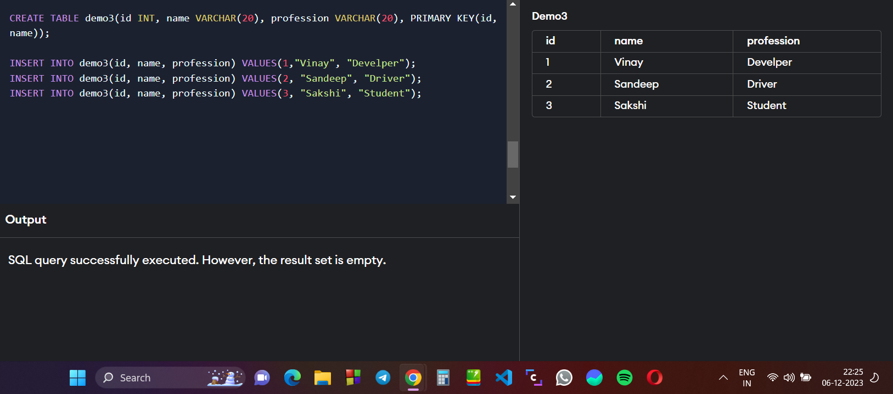

***DOMAIN INTEGRITY***

**Using DEFAULT CONTSRAINT in our student_result table :**

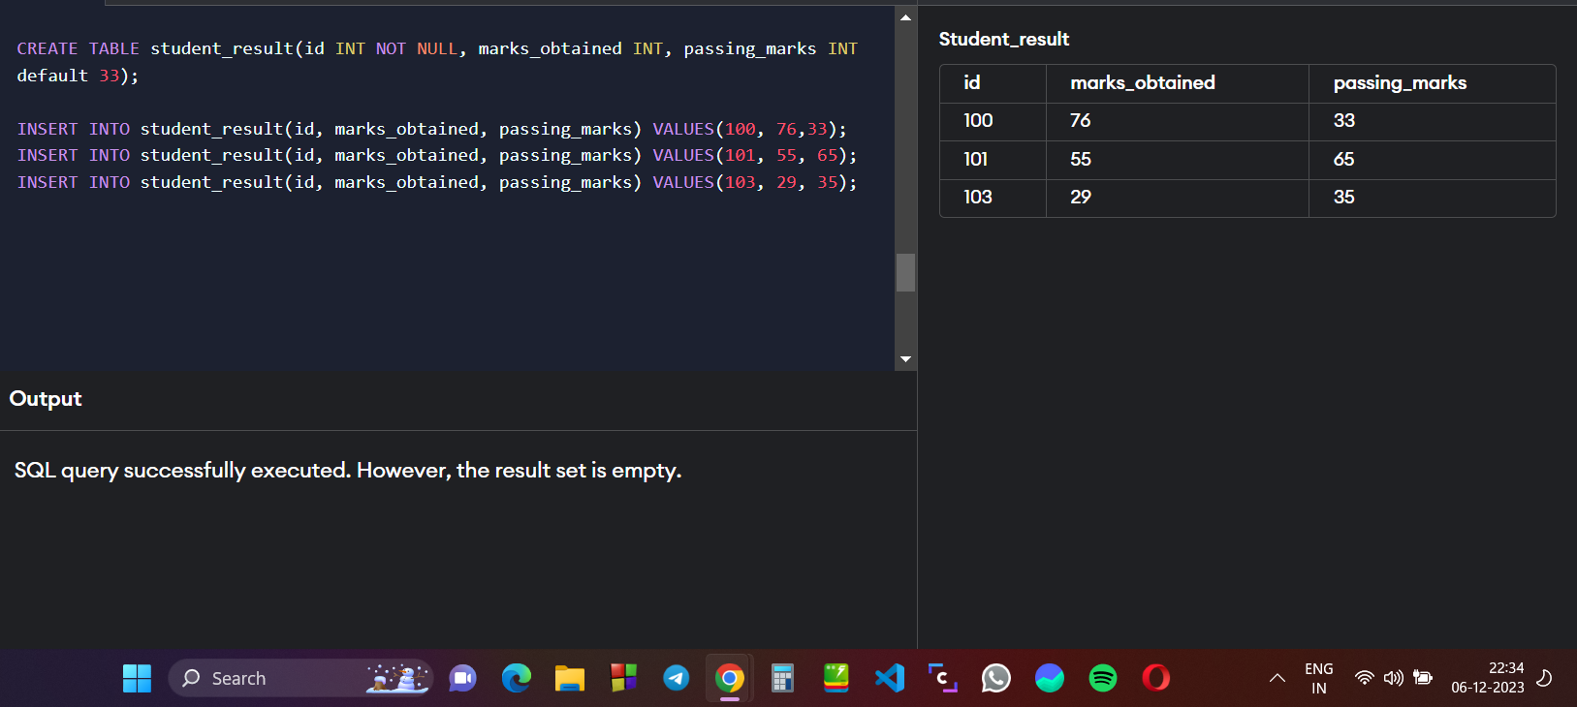

**Using CHECK CONSTRAINT to check the values entered in table :**

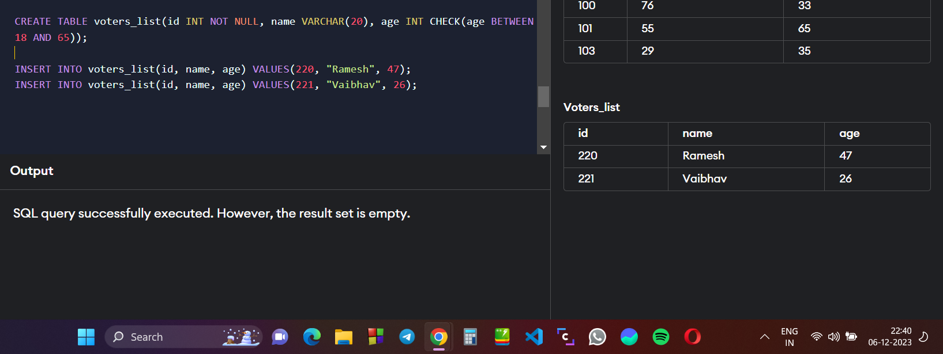

***REFRENTIAL INTEGRITY***

**Using FORIEGN KEY constraints to maintain integrity between two tables :**

